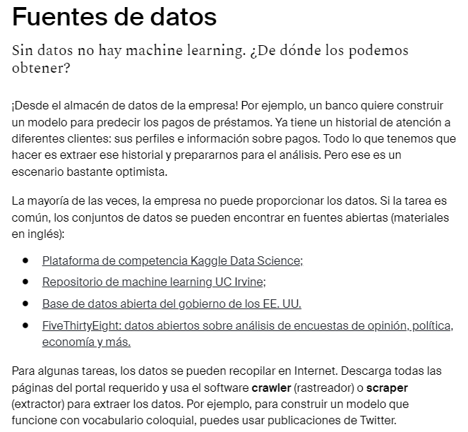



<https://www.kaggle.com/>

<https://archive.ics.uci.edu/ml/index.php>

<https://data.gov/about/>

<https://data.fivethirtyeight.com/>



<https://www.mturk.com/>

<https://toloka.ai/tolokers/>

Código:

target = []

for i in range(data.shape[0]):

labels = data.loc[*# < escribe tu código aquí >]*

true_label = *# < escribe tu código aquí >*

target.append(true_label)

data['target'] = target

import pandas as pd

data = pd.read_csv('/datasets/heart_labeled.csv')

target = []

for i in range(data.shape[0]):

labels = data.loc[i, ['label_1', 'label_2', 'label_3']]

true_label = int(labels.mean() > 0.5)

target.append(true_label)

data['target'] = target

print(data.head())

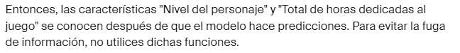

import pandas as pd

from sklearn.tree import DecisionTreeClassifier

from sklearn.model_selection import cross_val_score

data = pd.read_csv('/datasets/heart.csv')

features = data.drop(['target'], axis=1)

target = data['target']

model = DecisionTreeClassifier(random_state=0)

scores= cross_val_score(model, features, target, cv=5)

final_score= sum(scores) / len(scores)

print('Puntuación media de la evaluación del modelo:', final_score)

